Name: Gaurav Amarnani.
Class: CMPN DSE.
OOPM Lab 01.

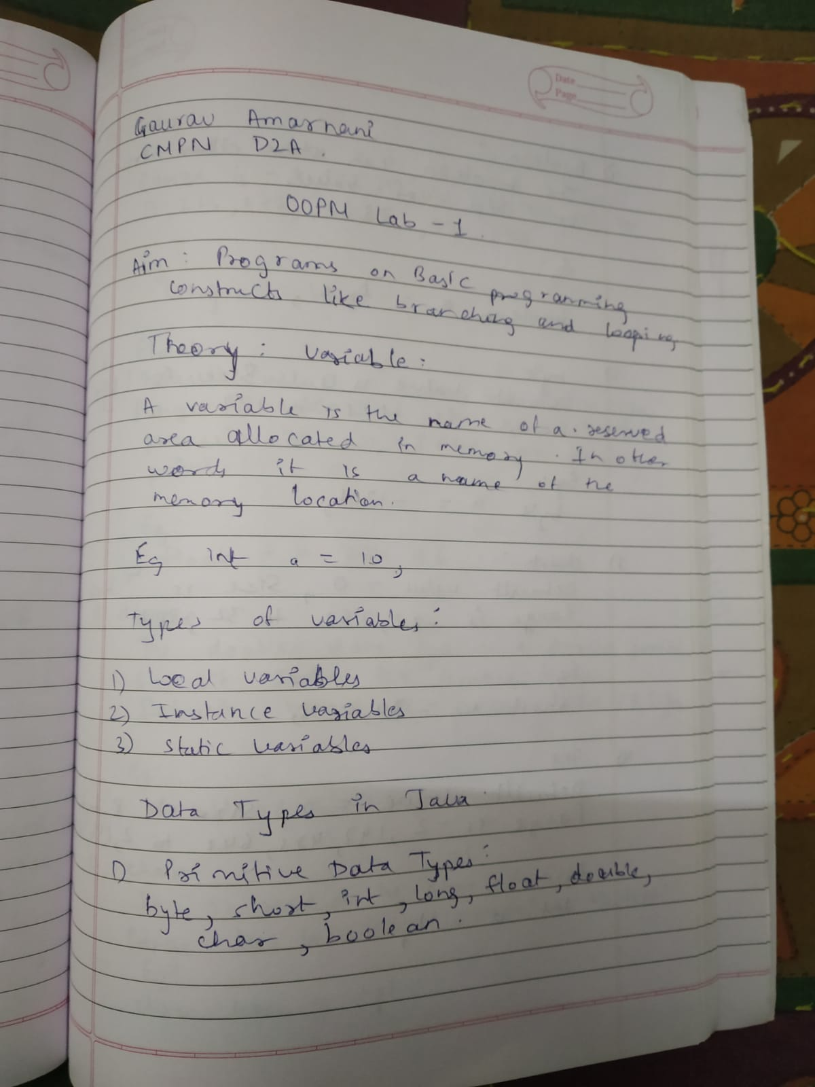

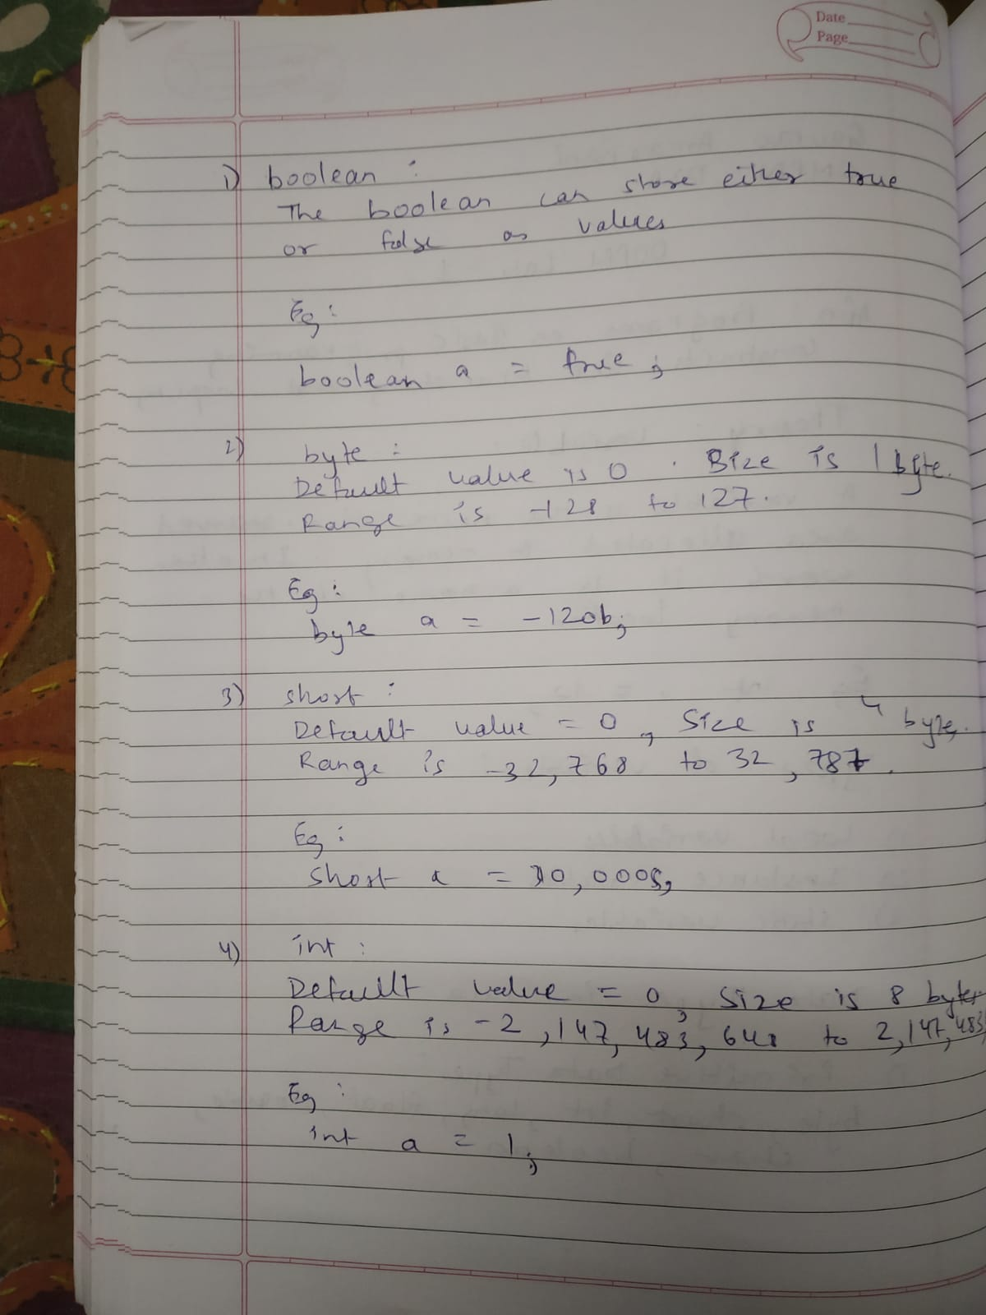

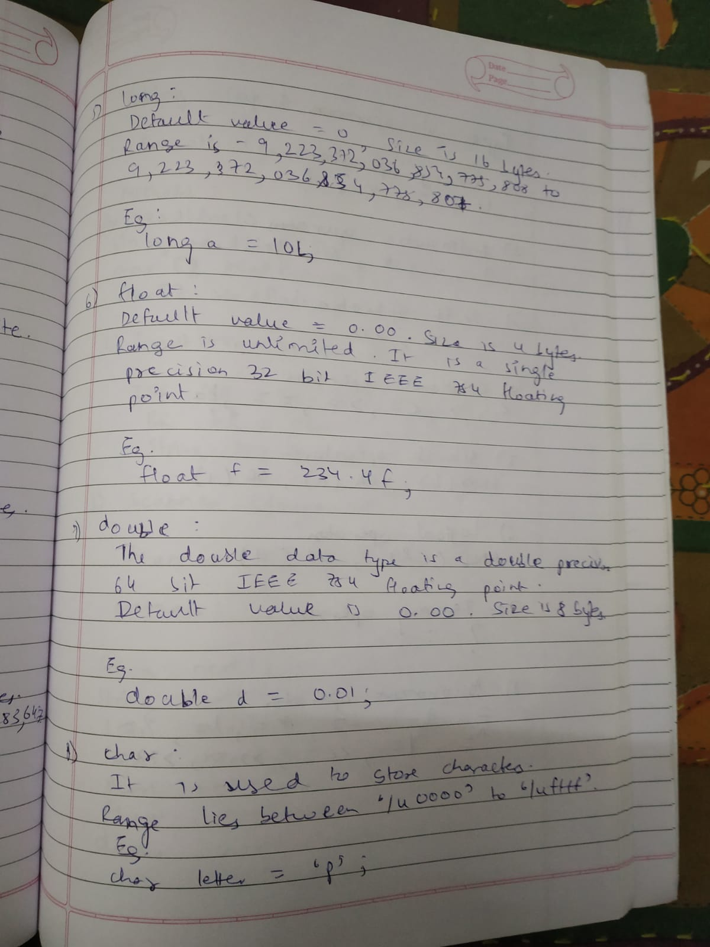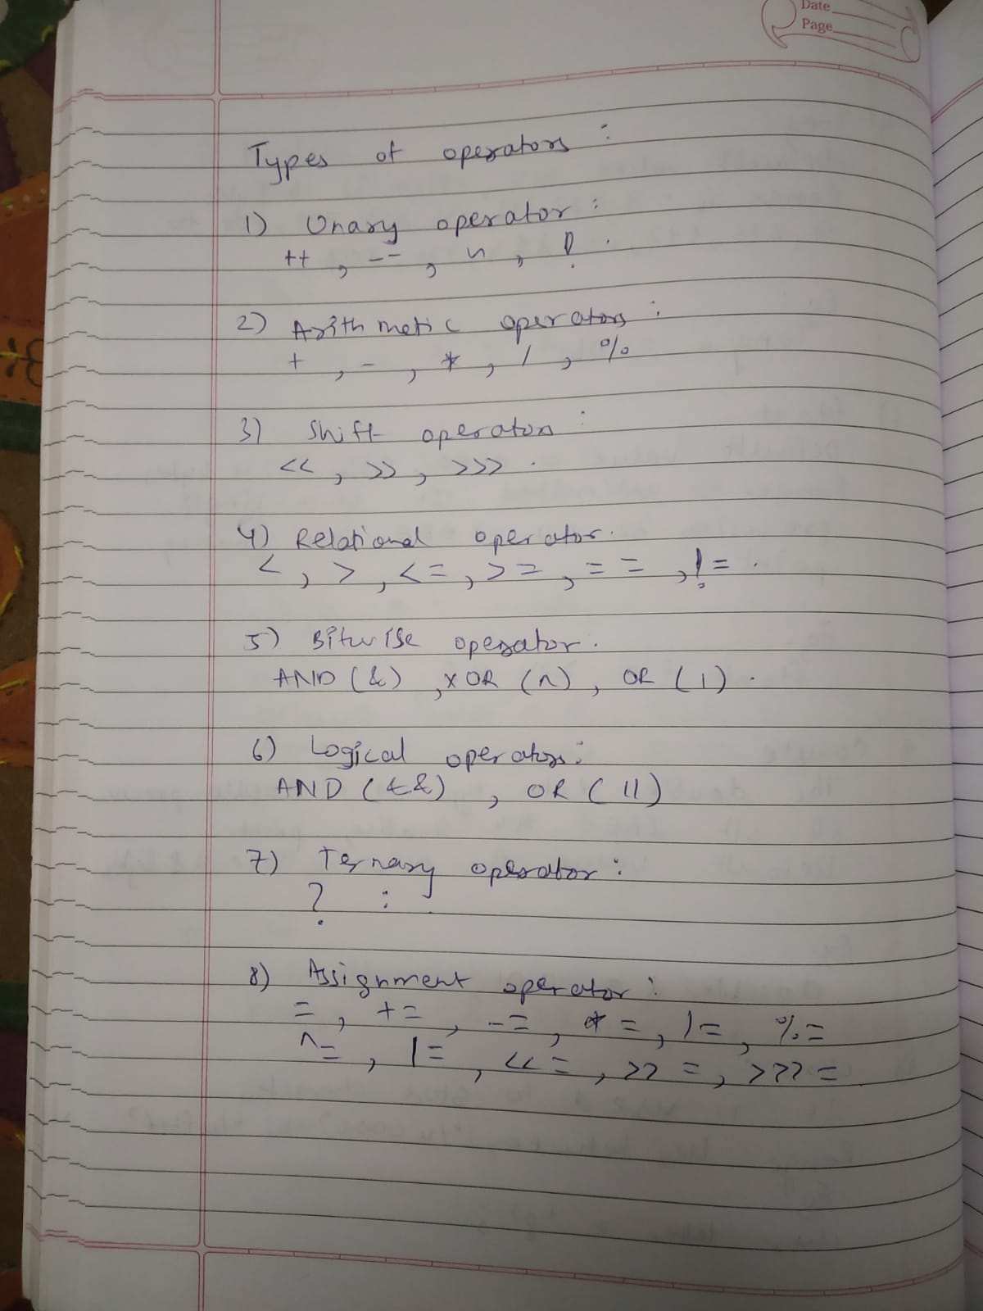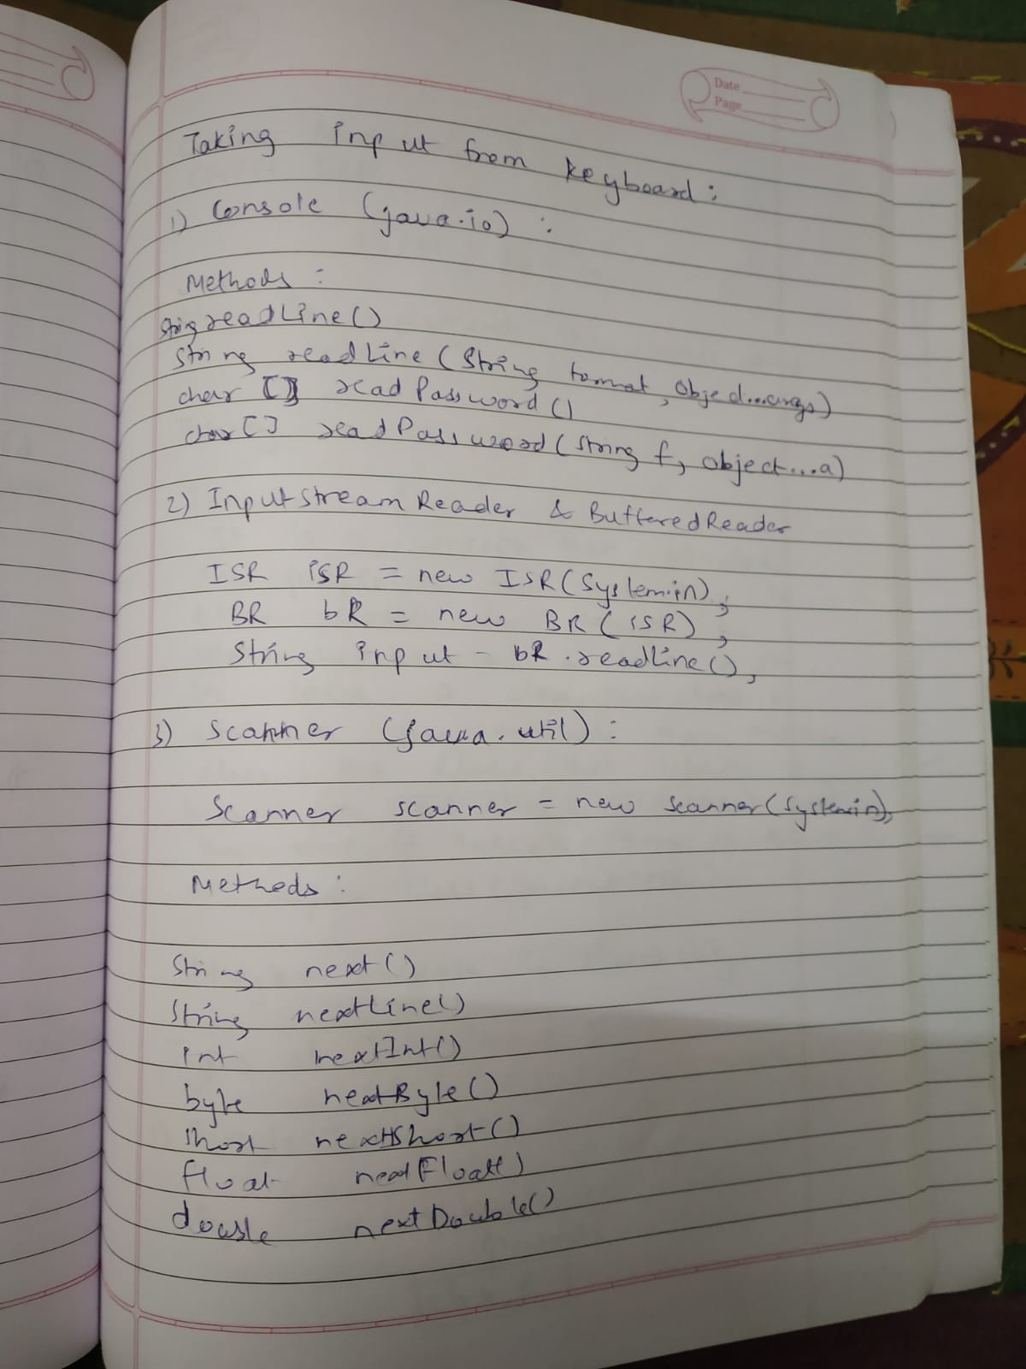

Programs:

Program 1: To implement a program to print the roots of quadratic equations.

package com.byGaurav.lab01;

import java.util.Scanner;

import static java.lang.System.*;

/**
* @author Gaurav Amarnani.
*/

public class RootsOfQuadrant {

public static void main(String...args) {

int t = 20;
Scanner scanner = new Scanner(in);
out.println("Enter value for a: ");
double a = scanner.nextDouble();
out.println("Enter value for b: ");
double b = scanner.nextDouble();
out.println("Enter value for c: ");
double c = scanner.nextDouble();
double root1, root2;

// Calculate the Determinant (b2 - 4ac)
double determinant = b * b - 4 * a * c;

if(a == 0)
out.println("Not a Quadratic Equation.");

else {
// Check if Determinant is greater than 0
if (determinant > 0) {

// Two Real and Distinct Roots
root1 = (-b + Math.sqrt(determinant)) / (2 * a);
root2 = (-b - Math.sqrt(determinant)) / (2 * a);

out.format("root1 = %.2f and root2 = %.2f", root1, root2);
}

// Check if Determinant is equal to 0
else if (determinant == 0) {

// Two Real and Equal Roots
// Determinant is equal to 0
root1 = -b / (2 * a);
out.format("root1 = root2 = %.2f;", root1);
}

// If Determinant is less than 0
else {

// Roots are Complex Number and Distinct
double real = -b / (2 * a);
double imaginary = Math.sqrt(-determinant) / (2 * a);
out.format("root1 = %.2f+%.2fi", real, imaginary);
out.format("\nroot2 = %.2f-%.2fi", real, imaginary);
}
}
scanner.close();
}
}

Output:

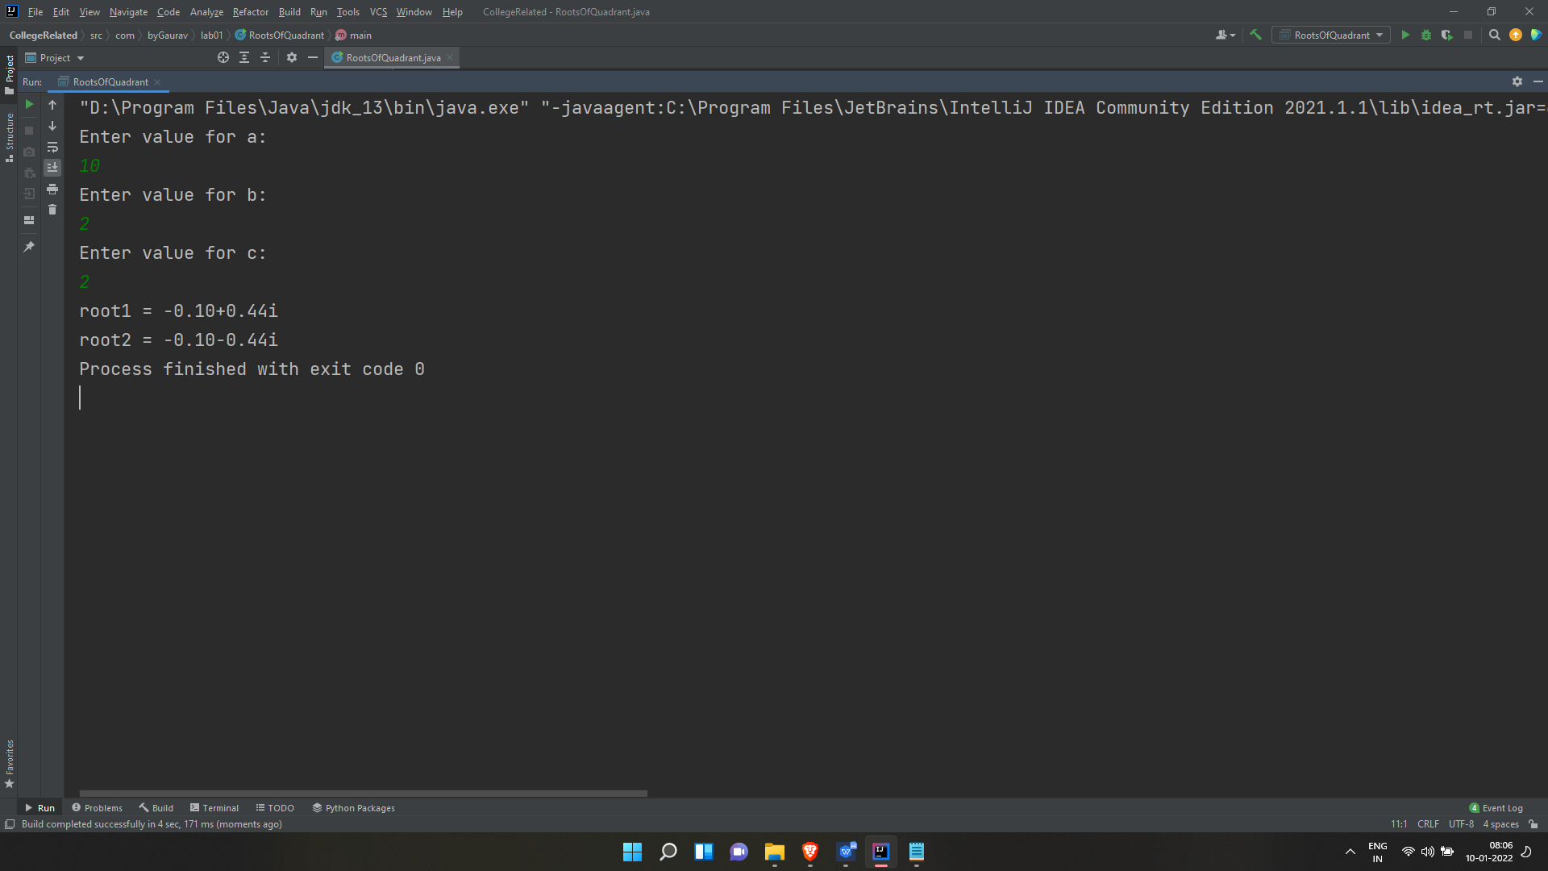

Program 2: To implement a Program to check if the entered no. is a prime no. or not.

package com.byGaurav.lab01;

import java.util.Scanner;

import static java.lang.System.*;

/**
* @author Gaurav Amarnani.
*/

public class PrimeOrNot {

public static void main(String...args){
Scanner scanner = new Scanner(in);
out.println("Enter the number you want to verify: ");
Integer input = scanner.nextInt();
if(checkIfNumberIsPrime(input))
out.println(input + " is a prime number.");
else
out.println(input + " is not a prime number.");
scanner.close();
}

public static Boolean checkIfNumberIsPrime(Integer number) {
for(int i = 2; i < number; i++) {
if(number % i == 0)
return false;
}
return true;
}
}

Output:

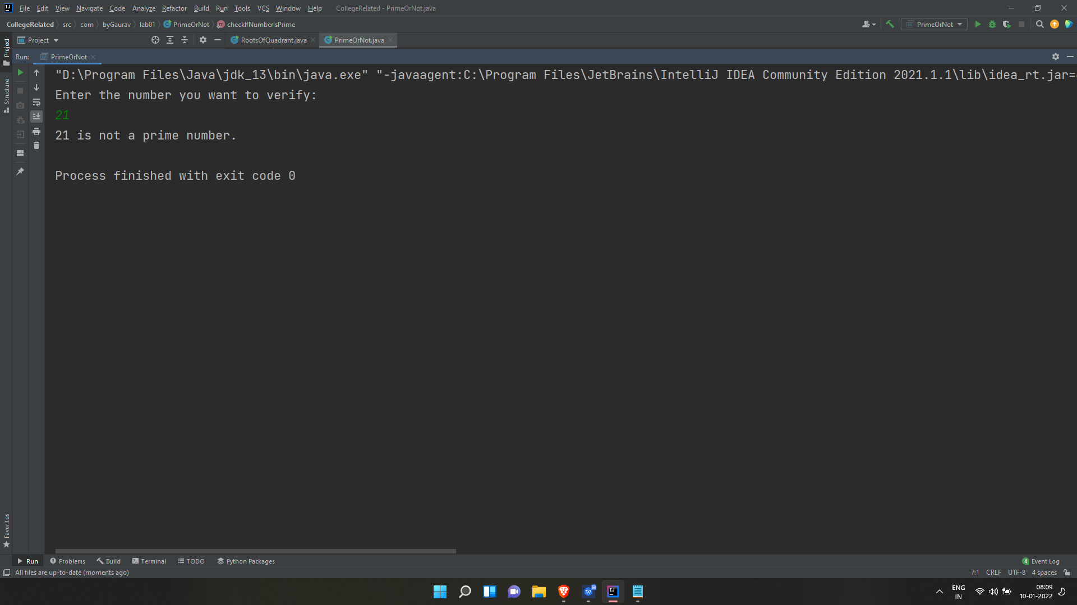

Program 3: To implement a Program to demonstrate the working of types of operators(Bitwise, Logical and relational) using switch case.

package com.byGaurav.lab01;

import java.util.Scanner;

import static java.lang.System.*;

/**
* @author Gaurav Amarnani.
*/

public class Operators {

private static Integer number1, number2;
private static Scanner scanner;

public static void main(String...args) {
scanner = new Scanner(in);
out.println("Choose from following: \n1.Bitwise Operator.\n2.Logical Operator.\n3.Relational Operator.");
switch (scanner.nextInt()) {
case 1:
takeInput();
demonstrateBitwiseOperator(number1, number2);
break;
case 2:
demonstrateLogicalOperator(true, false);
break;
case 3:
takeInput();
demonstrateRelationalOperator(number1, number2);
break;
default:
out.println("Please enter proper choice.");
main();
}
scanner.close();
}

public static void takeInput() {
scanner = new Scanner(in);
out.println("Enter Number 1: ");
number1 = scanner.nextInt();
out.println("Enter Number 2: ");
number2 = scanner.nextInt();
}

public static void demonstrateBitwiseOperator(Integer number1, Integer number2) {
out.println("Bitwise AND (number1 & number2) = " + (number1 & number2));
out.println("Bitwise OR (number1 | number2) = " + (number1 | number2));
out.println("Bitwise NOT (~ number1) = " + (~ number1) + " and (~ number2) = " + (~ number2));
out.println("Bitwise XOR (number1 ^ number2) = " + (number1 ^ number2));
}

public static void demonstrateLogicalOperator(Boolean value1, Boolean value2) {
out.println("Logical AND (true && false) = " + (value1 && value2));
out.println("Logical OR (true | false) = " + (value1 | value2));
out.println("Logical NOT (! false) = " + (! value2));
}

public static void demonstrateRelationalOperator(Integer number1, Integer number2) {
out.println("number1 == number2 = " + (number1 == number2) );
out.println("number1 != number2 = " + (number1 != number2) );
out.println("number1 > number2 = " + (number1 > number2) );
out.println("number1 < number2 = " + (number1 < number2) );
out.println("number1 >= number2 = " + (number1 >= number2) );
out.println("number1 <= number2 = " + (number1 <= number2) );
}
}

Output:

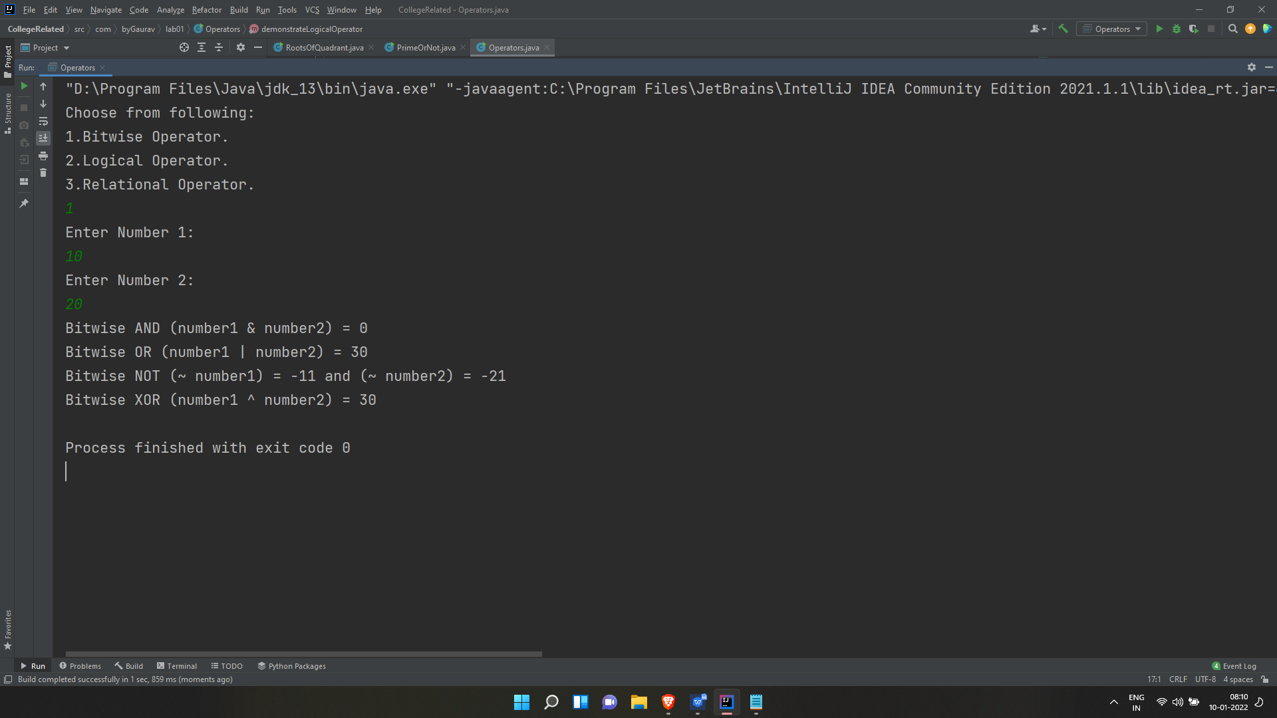

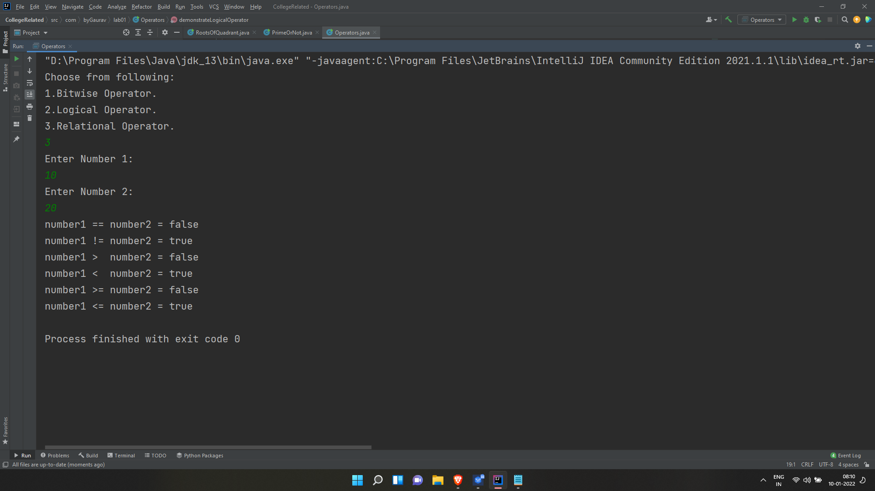

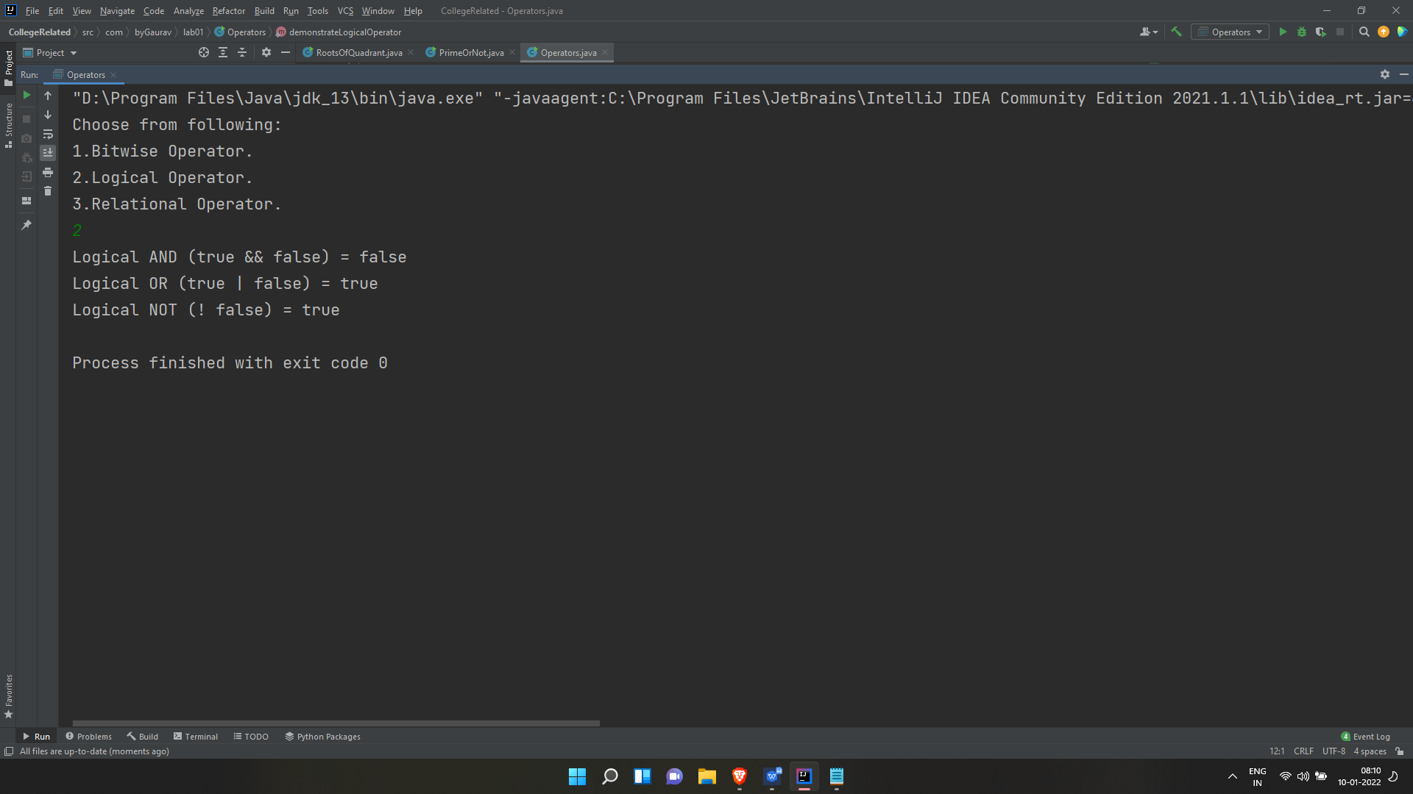

Program 4: WAJP Print the Fibonacci series upto the nth term taking the value of n from the user.

package com.byGaurav.lab01;

import java.util.Scanner;

import static java.lang.System.*;

/**
* @author Gaurav Amarnani.
*/

public class FibonacciSeries {
public static void main(String...args) {
Scanner scanner = new Scanner(in);
out.println("Enter the nth Term: ");
Integer nthTerm = scanner.nextInt();
fibonacciSeriesUpToNthTerm(nthTerm);
scanner.close();
}

public static void fibonacciSeriesUpToNthTerm(Integer limit) {
if(limit > 0) {
Integer first = 0, second = 1, temp;
out.print("Fibonacci Series: " + first + " " + second + " ");
while (second <= limit) {
temp = first + second;
first = second;
second = temp;
if (second < limit)
out.print(second + " ");
}
}
else {
out.println("Wrong Input.");
}
}
}

Output:

